Content Strategy
Georgia Humane Society is a 501(c)3 non-profit dedicated to rescuing at-risk cats from shelters and unsafe living situations. It has a strong following of animal rights activists living in Douglas County and people who have adopted from the rescue in the past. GHS is using Facebook as their only social media platform, where it posts frequently and is consistent with the themes of its content. It has an adoption story showcase called “happy tails” that has consistent messages and organizational voice, but that voice does not carry over to the rest of its content. The organization has a decent amount of engagement on its posts, but GHS is not responding with content that builds relationships with its audience or making efforts to branch out to new audiences.
There is plenty of room for GHS to grow through social media. Since its reach is limited to Facebook users, GHS has the opportunity to create profiles on other platforms, without having to overhaul an existing account. Georgia Humane Society could also benefit from evaluating the messages behind their content, instead of posting irrelevant information for the sake of posting. A threat to the organization’s social media reputation is that it allows volunteers to speak on behalf of the organization, but this could be easily corrected by scheduling time and creating sample responses that are in-line with the organizational voice.
The main publics Georgia Humane Society should focus on are pet lovers, potential adopters, and potential volunteers. Their mission is to provide the cats in their care with a better life, and by targeting people who could adopt or care for the cats GHS is housing, it could further achieve its mission. These new markets present the opportunity to inform people the resources GHS provides, outside of just cat adoptions.
The goal of this campaign is to allow Georgia Humane Society to boost awareness and increase engagement, whether it be with adopters or volunteers, through social media. This can be achieved by expanding onto new platforms, crafting a brand voice that can be used across all social media, and strategically planning content that will educate, encourage, and engage the audience. Below are some key topics that will be the focus of this campaign.
- Rescue/Shelter: Use this topic as an opportunity to educate the audience on the differences between a shelter and a rescue, how they function, and the work that goes into caring for the animals. This is also an opportunity to showcase your partnerships with other organizations in the community since GHS pulls from local overpopulated shelters.
- Responsible Pet Ownership: This could be engaging and informative. Talk about how much responsibility it is to own an animal, proper veterinary care, and promote a healthy lifestyle. This could be anything from veterinary recommendations to how to trim your cats’ claws. This is also an opportunity to engage with the audience on how being a pet owner makes them feel. Use their stories on your social media pages and congratulate them on being a pet parent.
- Trap-Neuter-Release (TNR) Programs: TNR programs are a great way to help your community’s cats and get involved. This is a great option for people who cannot own an animal but want to get involved in animal rescue. Talk about Douglas County’s community cats program or the effect TNR can have on maintaining a healthy feral cat population.
- Volunteering: Non-profits would be useless without the help of volunteers. Share your volunteers’ stories on social media, whether its foster parents, adoption helpers or the cat house cleaners. Show your audience the benefits of donating their time or money to GHS.
- Adoption: The goal of GHS is to find the animals in its care their forever home. The “Happy Tails” stories are already a great strategy to get your audience involved with the organization. Build a relationship with the people who have adopted from GHS in the past and share their stories. Another opportunity is to have a place on social media where the audience can see all of the cats who are available for adoption.
This campaign will attempt to partner with Sterling Davis (@the_original_trapking) since his mission aligns with GHS. Davis is an Atlanta native focused on informing the community about the importance of trap-neuter-release programs and treating animals with respect. His goal is to end the stereotypes around cat rescue and encourage men and the African American community to get involved. He has over 34,000 followers, is an expert in his field, and has a diverse audience that would allow for GHS to branch out.
The campaign would also benefit from getting local blogger, Joleen Pete (@lovejoleen), involved with the organization. She is a mommy blogger working at Atlanta.net, with a focus on family and volunteer opportunities. Not only would she be the perfect candidate to adopt from GHS, but she could also vouch for how great of an experience it is to volunteer or adopt from the rescue. She has a smaller following of 2,937 Twitter followers, but her connections with Atlanta.net and her beat allow for GHS to reach potential adopters or volunteers across the Metro Atlanta area.

Brand Voice Strategy
Character/Persona  Casual, Playful, Easy-going, and Positive | DO: Looking for a new best friend? Our kittens are waiting for you! What do you think the PURR-fect cat looks like?  DO NOT: There isn’t a day that goes by that are kittens don’t wish for a forever home. Will you be the one to make their dreams come true?
Tone  Personal, Informative, and Encouraging | DO: Zeppelin found his forever home! This playful ball of fluff couldn’t contain his excitement when his new mom walked through the PetSmart doors. Happy Tails, Zeppelin!  DO NOT: Come to Douglasville PetSmart this weekend so you can go home with a cat like Zeppelin.
Language  Simple and Fun | DO: Squiggles is looking good and FELINE better after her visit with Dr. Marcelli! Are you looking for the perfect vet for your pet? Reach out to us and we’ll put you in contact with the right people!  DO NOT: Squiggles had to visit Dr. Marcelli for Borborygmi in her tummy and they had a Uberschwinger artefact during her X-ray.
Purpose  Engage, Educate, and Encourage | DO: Just rescued this little ball of cattitude! We picked her up so quick, DC animal shelter didn’t have time to name her. We’d love to hear your suggestions!  DO NOT: Meet Wilco. She’ll be available this week at the Douglasville PetSmart.

Editorial Calendar
 | Facebook | Instagram | Twitter
Feb. 24 | • #mondaymewd post | • Cat Showcase – Wendy | • #mondaymewd post  • Discussion Question: What’s the one thing in your house that your cat HAS to play with?
Feb. 25 | • Weekly Health Hotline post – the importance of getting your cats spayed/neutered | • Day in the life of a Volunteer (Stacy) on Story | • Fat Tuesday Twitter Post #mardigras
Feb. 26 |  | • Cat Showcase – Martin  • Find feel-good cat story to share on Instastory | • Find feel-good cat story to retweet
Feb. 27 | • Post pictures of all cats who are going to be at the Adoption Event this weekend (1post) |  | • Donation list
Feb. 28 | • Adoption updates tagging the new owners | • Cat Showcase – Piper  • Adoption Event setup on Instagram Story | • Cat Showcase - Piper
Feb. 29 | • CATurday Facebook Live – Clipping your cats’ nails.  • Adoption updates tagging the new owners | • Cat Showcase – Clover (Make it St. Patrick’s Day themed) | • Cat showcase – Clover (Make it St. Patrick’s Day themed)
March 1 | • Adoption updates tagging the new owners | • Happy Tails update! Post pictures of a couple of the cats with their forever families. In the comments list how many cats were adopted that weekend! | • Sterling Davis (@TrapKingDavis) shoutout

Sample Content
Facebook Live
Hi Everyone! Thanks for joining! I’m Katie, a volunteer at Georgia Humane Society. Are you tired of your cats clawing the furniture or making monthly visits to the vet to have their nails trimmed? In this Facebook live, I am going to walk you through the easiest way to trim your cats’ nails!
Let’s get started!
So first, you’ll need a good set of clippers! We use Resco Original Cat Nail Clippers since they’re gentle on cats’ paws. Once you find your clippers, you’ll want to set the mood for your cat’s manicure. You’ll want your cat to be as relaxed as possible, so find a quiet room and a comfy chair. Get your cat while they still have a full belly or is getting ready for a nap. This is one of our cats, Wilco. She just ate and now we are going to love on her a little bit.
Now that she’s calm, we’re going to turn her so her booty is facing me. Start by gently taking her paw. If she pulls away, that’s okay. We’ll wait for her to relax and try again. Take her paw and gently press so her claw extends. You’re just going to cut the very tip of her nail! You’re only going to cut this white part of the nail because below that is the Quick! It is very sensitive and could cause your cat to panic if nick it! You repeat this process until your cat’s nails are looking fresh.
At GHS, we only cut our cats’ front nails, but if you want to trim all four paws, go for it! The younger your cat is when you start clipping their nails, the better. Just like humans, cats thrive on routine. Never get angry or aggressive with your cat. Move at their pace. The more they are exposed to positive nail clipping experiences, the easier it will be to trim their nails in the future.
Thanks for joining and if you have any questions, reach out to GAHSCats anytime on Facebook, Instagram, or Twitter!
Instagram
Copy | Image
Meet Biscuit! This fun-loving guy has been a volunteer favorite since he arrived at GHS. He loves climbing the cat tower, Temptations Treats, and his litter-mate, Gravy! He is neutered, FELV/FIV negative, and up to date on shots. Come see his CATTITUDE in person this weekend! #GAHSCats | 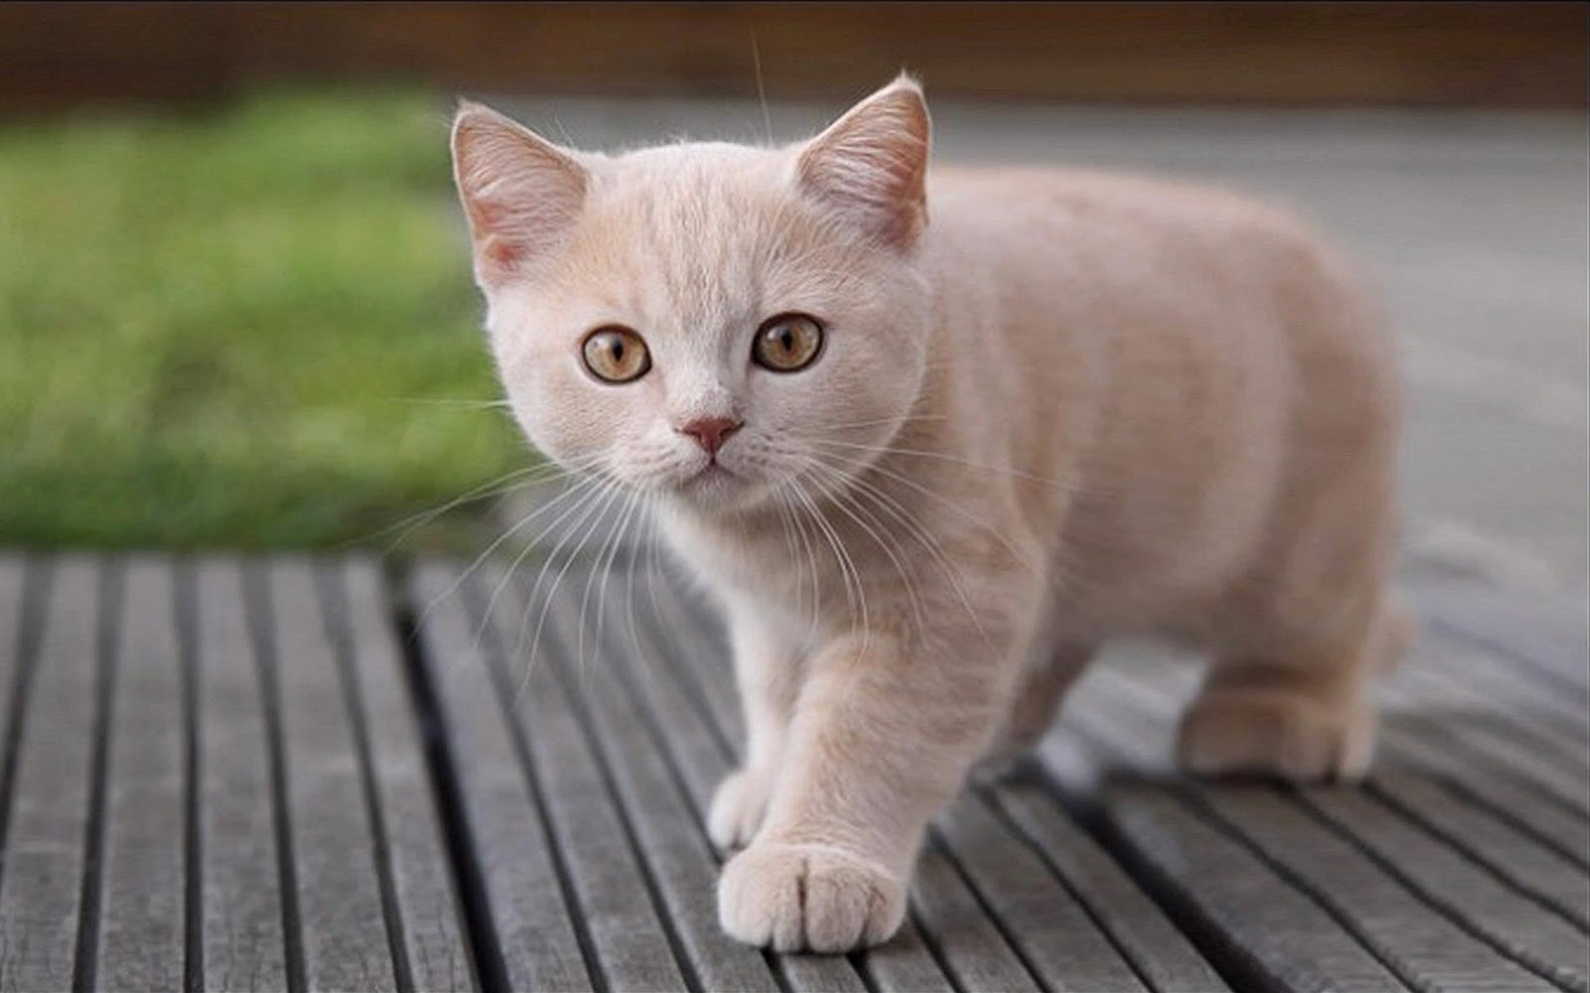
Introducing Weasley! Named after Ron Weasley, this sweet guy always wants attention and is brave enough to protect you from a swarm of wicked kittens. Weasley has been with GHS for over a year, FELV/FIV negative, and up to date on shots. See if he casts a spell on you this Saturday. #GAHSCats  (Tag Douglasville PetSmart in the Location) | 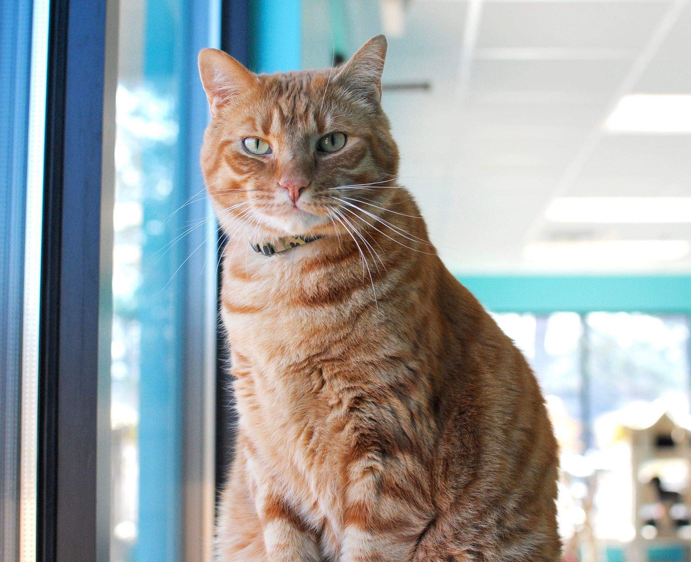
Buffy and 4 other fur-babies found their forever families today! Jane and Joe adopted Buffy after deciding that they need one more cuddle buddy this Valentine’s Day! Thank you for adopting from GHS!  Happy Tails Buffy, Rex, Zeppelin, Denver, and Chuck!  (Tag the couple in the Instagram post and PetSmart Charities in the location) | 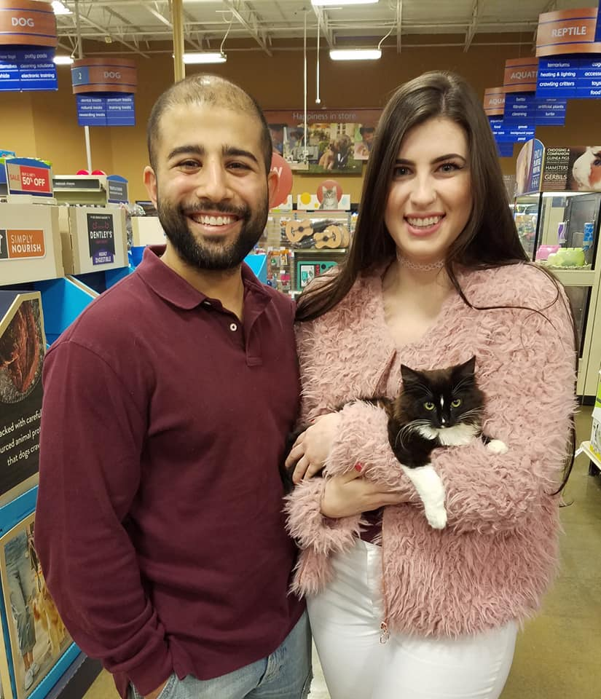
Say Hi to Opal! This girl is as sweet as can be, but just like the mineral, she has a fiery side if she sees a string toy! She enjoys being brushed, chasing everything, and sleeping as close to people as possible. She is spayed, FELV/FIV negative, up to date on shots, and available this weekend! #GAHSCats | 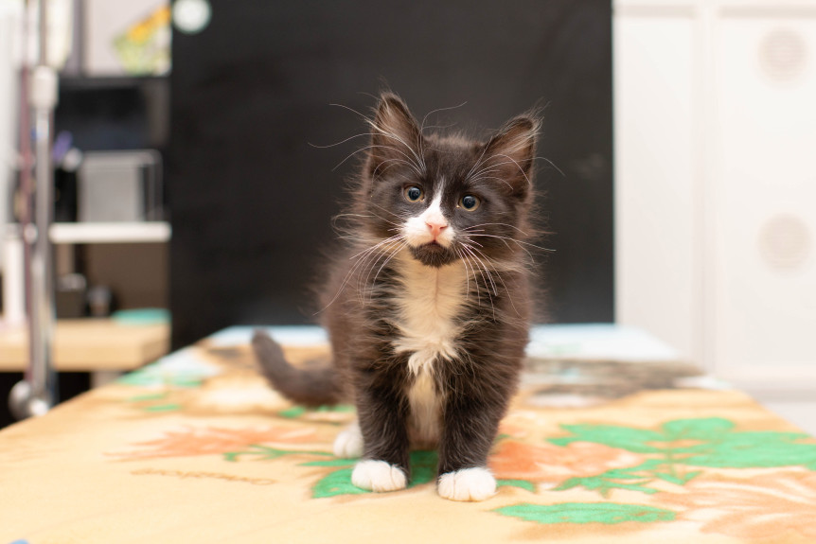
Meet our newest addition, Edward! Did you know cats can snore? We didn’t until Edward came through our doors. This sleepy boy could be a morning kitten if morning was around noon!  He is neutered, FELV/FIV negative, up to date on shots, and will be available this weekend! #GAHSCats | 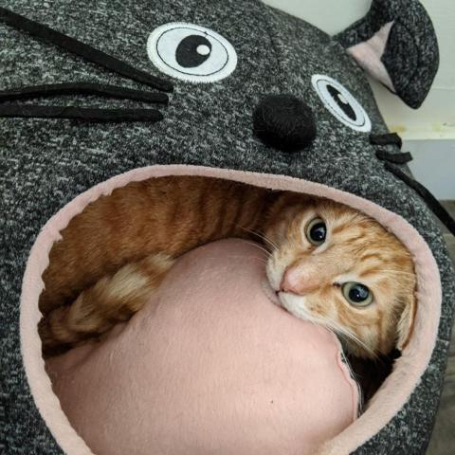

Twitter
Date | Time | Tweet | Link/Attachments | Extra Info
Daily | ASAP | @_____ Thank you for adopting from GHS! Happy Tails cat’s name!  @______ Looking good & feline better! Thanks for adopting from GHS. Happy Tails cat’s name!  @______ Cat’s Name is PAWSOME! Thank you for adopting from GHS. Happy Tails! |  | Anytime anyone tweets @ the organization about the animals they adopted from GHS!
Weekly | 12:30 pm | Example:  Introducing Weasley! This sweet guy always wants head scratches and is brave enough to protect you from a swarm of wicked kittens. Weasley has been with GHS for over a year, felv/fiv negative, and up to date on shots. Come see this magical cat on Feb. 21! #GAHSCATS |  | Showcase an adoptable cat.  - Name  - Personality Traits  - When he is available for adoption.  - #GAHSCATS  - Insert Picture
Feb 21,  2020 | 3:00 pm | Is your cat a player? Our partner, West Georgia Spay Neuter Clinic has you covered! Grab the carrier and check out their Holiday discounts! | www.westgeorgiaspayneuter.com
Feb 23,  2020 | 4:00 pm | We love these heartwarming rescue stories! Anyone dying for a purrito of their own? | https://t.co/aEWA0vUFQ5?amp=1
Feb 24,  2020 | 9:30 am | Happy Monday Everyone! Don’t forget that #cattitude is everything! #mondaymorningmewd | 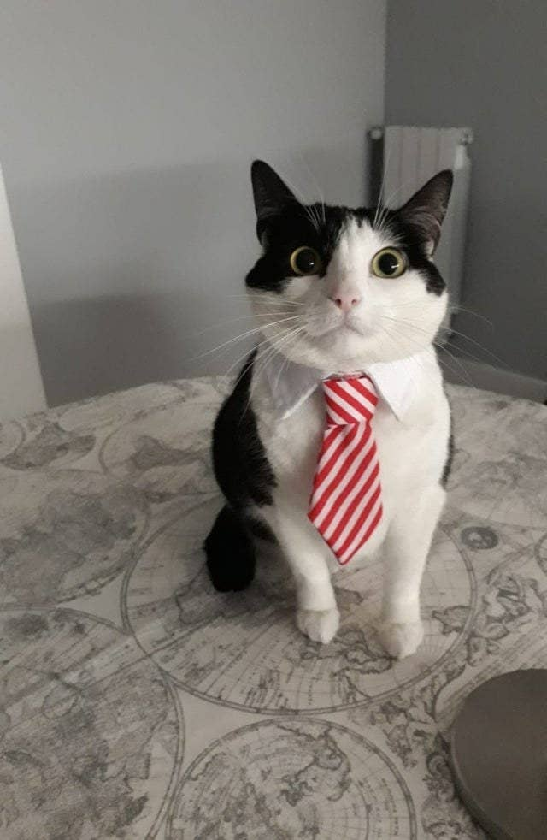
Feb 25, 2020 | 1:00 pm | Fat Tuesday is the best Tuesday! This is our #mewd because carnival season is almost over! | 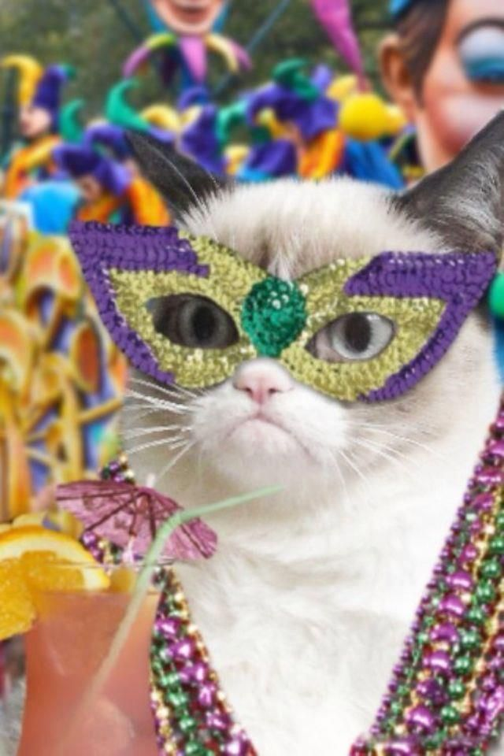
Feb 27, 2020 | 2:00 pm | Did you know cats spend up to 50% of their day cleaning themselves? We guess that would make you pretty hungry.  We’re always appreciative of keeping our kittens’ bellies full. With Chewy.com, You can send a tax-deductible donation to our front door with just a few clicks! | 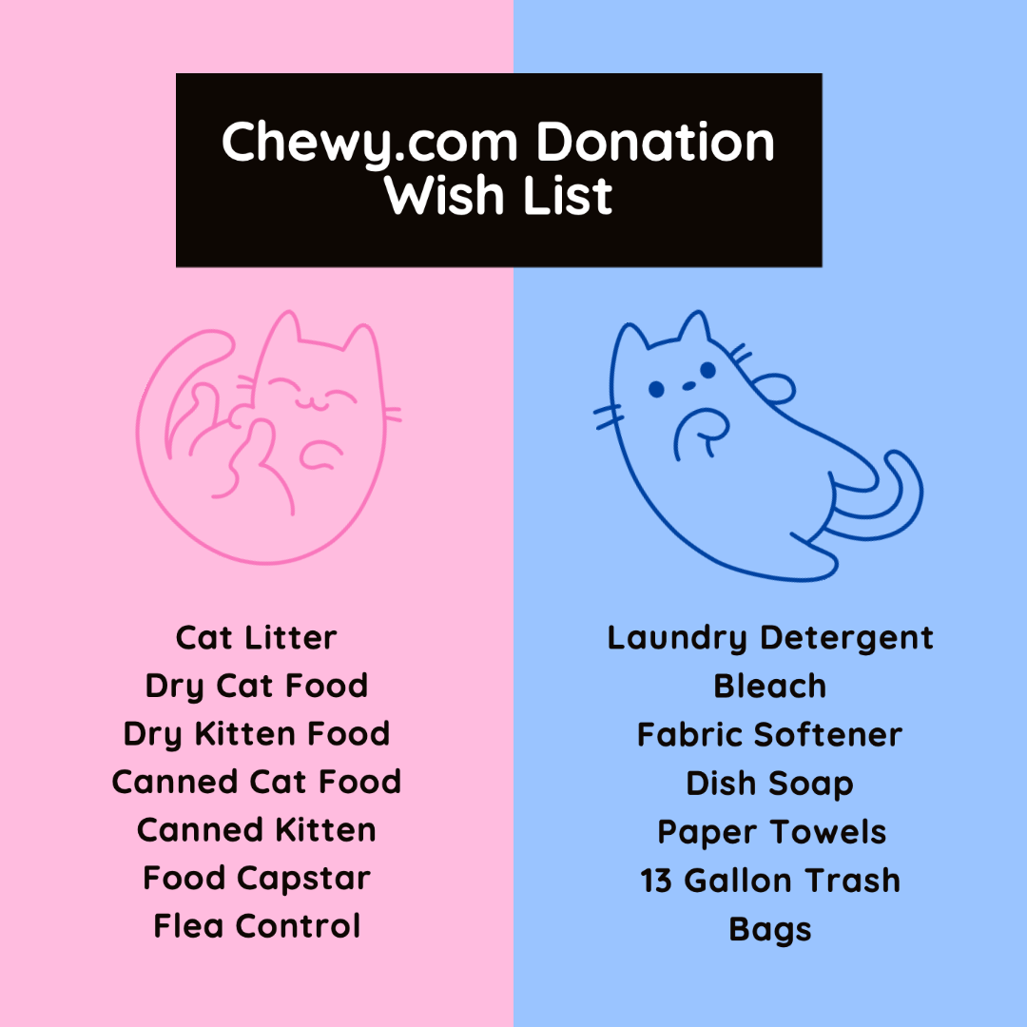  https://www.chewy.com/rp/9448
March 1, 2020 | 1:00  pm | Check out @TrapKingDavis ‘s dedication to TNR! We love to see it!! | Sterling Davis Tweet | Retweet with this comment!
March 2, 2020 | 4:00 pm | All of this rain is the perfect excuse to grab your cat and a cup of coffee! Who is your rainy day cuddle buddy? | 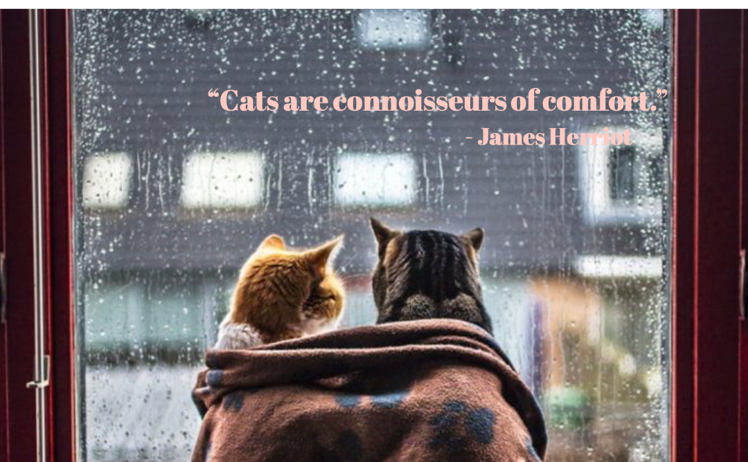 | If it’s not rainy, save this post for another day!
March 3, 2020 | 5:00 pm | It’s rare that we cant help! We hope he finds a loving home! | Free to a good home Tweet

